**Experiment-6**

**Aim**:To design obstacle detector using ultrasonic sensor.

**Apparatus**:ultrasonic sensor,arduino,breadboard,wires

**Circuit**:

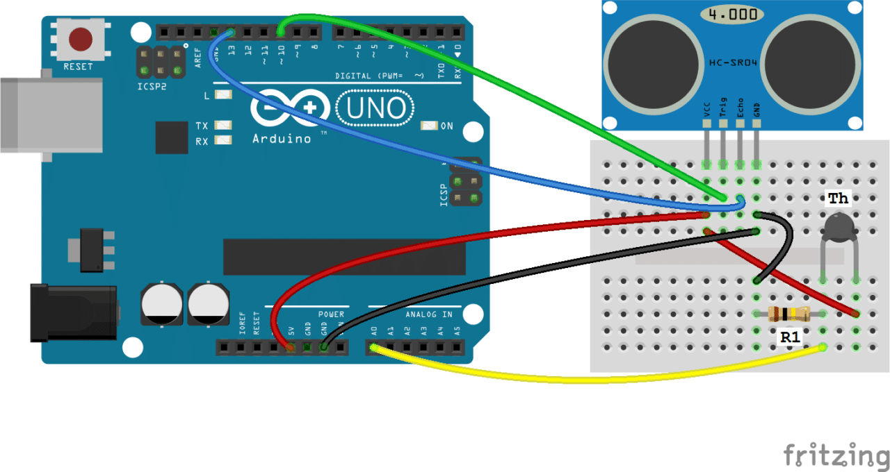

**Program**:

Const int trigPin=9;

Const int echoPin=10;

long duration;

int distance;

void setup()

{

pinMode(trigPin, OUTPUT);

pinMode(echoPin, INPUT);

Serial.begin(9600);

}

Void loop()

{ digitalWrite(trigPin, LOW);

delayMicroseconds(2);

digitalWrite(trigPin, HIGH);

delayMicroseconds(2);

digitalWrite(trigPin, LOW);

duration = pulseIn(echoPin, HIGH);

distance= duration*0.034/2;

serial.Print(“Distance: “);

serial.Println(Distance);

}

**Result**:

The obstacle detector was created using ultrasonic sensor.

**Learning and Outcomes**:-

1. Use of ground and resistance in circuit.

2. How to connect Ultrasonic sensor in circuit.

3. Resistance must be of 10 kilo ohm not less than that.

4. To work on both analog and digital pins.

**PROBLEM & TROUBLESHOOTING**:

1. Mistake in coding in statement.

2. Logical mistake happened in connection.